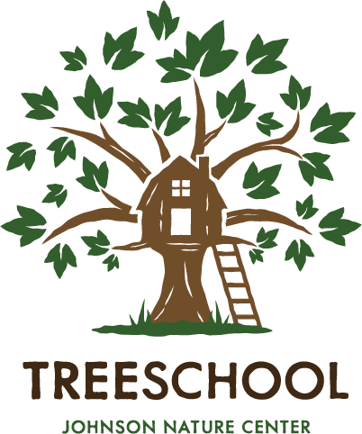

Food Services Agreement

Parent/Guardian,

TreeSchool will not provide a snack, lunch or other food to students. By signing this form you are agreeing that you (guardian) will be expected to provide all nut-free snacks and sack lunches for students without items that require additional heating or cooling.

I acknowledge that I have received this notice:

________________________________________ ___________
Parent/Guardian Date

